SAFE WORK PROCEDURE TEMPLATE
This template is intended to assist member businesses develop their own workplace forms. The following information should be used as a guide only. Any wording changes, other than those to insert a business name, may change the context, meaning or purpose of the form. We recommend you receive advice from the Victorian Chamber of Commerce and Industry prior to making such changes.

Contacting the Victorian Chamber of Commerce and Industry
The Victorian Chamber’s team of experienced health, safety and wellbeing and workplace relations advisors can assist members with a range of health, safety, wellbeing, employment, human resources and industrial relations issues.
Our experienced health, safety and wellbeing and workplace relations consultants can also provide assistance to both members and non-members on a range of more complex matters for a fee-for-service. The consultants can, among other things, provide health, safety and wellbeing consulting and training to employees, conduct investigations and provide representation at proceedings at the Fair Work Commission.
For assistance or more information, please contact the Advice Line on (03) 8662 5222.
Disclaimer
The information contained in this document has been prepared by the Victorian Chamber of Commerce and Industry in this format for the convenience and benefit of its members and is provided as a source of information only. The Victorian Chamber does not accept responsibility for the accuracy of the information or its relevance or applicability in particular circumstances. The information does not constitute, and should not be relied on, as legal or other professional advice about the content and does not reflect the opinion of the Victorian Chamber, its employees or agents. The Victorian Chamber and its employees, officers, authors or agents expressly disclaim all and any liability to any person, whether a member of the Victorian Chamber or not, in respect of any action or decision to act or not act which is taken in reliance, whether partially or wholly, on the information in this communication. Without limiting the generality of this disclaimer, no responsibility or liability is accepted for any losses incurred in contract, tort, negligence, or any other cause of action, or for any consequential or other forms of loss. If you are uncertain about the application of this information in your own circumstances you should obtain specific advice.

SAFE WORK PROCEDURE TEMPLATE

PPE required: [delete images that are not relevant to this task & list any other PPE considered necessary to safely complete the task, but not noted here]

Location of task/equipment: | Insert location | Department: | Name relevant

SAFETY PRECAUTIONS: [delete images that are not relevant to this task & list any other rules that relate to this task]

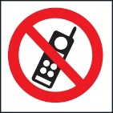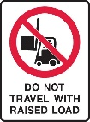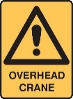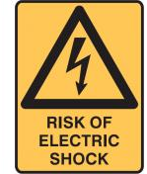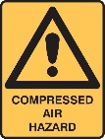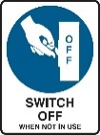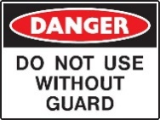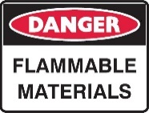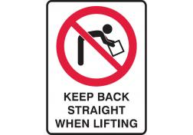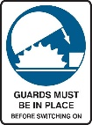

- e.g. Not undertaken for more than 2 hours at a time

Operational steps (including safety control measures from risk assessment)
PRE-START: [INSERT STEPS AS REQUIRED]
- All high-impact energy sources have been identified
- Statutory requirements/Authorisations
- Certification of plant/equipment/structure
- Certification of workers
- Environmental impact considerations
- Spotter(s) needed
- Notification to all associated personnel (incl workers and neighbours)
- Review of specific hazards to be faced
- Access to appropriate hazard control equipment
- Check PPE for suitability to hazard(s), individual needs, fit — and wear as required
- Weather conditions/changes expected

OPERATING : [INSERT STEPS AS REQUIRED]

EMERGENCY/ISOLATING/TROUBLESHOOTING [INSERT STEPS AS REQUIRED]
- All energy sources have been isolated where possible, and emergency procedures appropriate to the energy considered
- Report all incidents immediately
END OF TASK:
- Appropriate housekeeping and clean-up of environment

Training requirements for the safe operation of this procedure
- Induction training
- General WHS/OHS legislative awareness
- Manual handling (general)
- Noise
- Hazardous substances
- Electrical hazards
- Use of PPE
- Safe machine operation
- Maintenance & housekeeping procedures
- Injury, illness, damage and near-hit notification
- Accident notification
- Fire and emergency procedures

Related Documents:
(e.g. Job Safety Analysis for a Press Operation)
(e.g. Training matrix for…)
Date: | Signature of Manager:
Review Date:

Date | Name of Worker | Signature

COMPETENCY ASSESSMENT
This can be used to record whether or not a worker is competent to perform the task outlined in the Safe Work Procedure.
Instructions:
Observe the worker to see if they perform the task as described in the procedure and use the appropriate Personal Protective Equipment [PPE].
Ask the participant questions about why they need PPE, why the steps must be taken in the stated order etc — to test their understanding.

TRAINEE
 | Print name: |  | Assessment
Signature: |  | Competent |  | Not Competent
Understands what is required to perform this procedure under supervision
Has demonstrated a clear understanding of performing the activity and may perform activities without supervision
Has demonstrated that they are capable of training others in this activity
INSTRUCTOR
Print name: |  | Date:
Signature:

Completed competency assessment to be returned to: [INSERT NAME/POSITION]

Copy 1: Personnel file of each worker.
Copy 2: Safe Work Procedure Competency File.

Record on the training matrix for each worker.

