RISK ASSESSMENT MATRIX
This template is intended to assist member businesses develop their own workplace form. The following information should be used as a guide only. Any wording changes, other than those to insert a business name, may change the context, meaning or purpose of the template. We recommend you receive advice from the Victorian Chamber of Commerce and Industry prior to making such changes.

Contacting the Victorian Chamber of Commerce and Industry
The Victorian Chamber’s team of experienced health, safety and wellbeing and workplace relations advisors can assist members with a range of health, safety, wellbeing, employment, human resources and industrial relations issues.
Our experienced health, safety and wellbeing and workplace relations consultants can also aid both members and non-members on a range of more complex matters for a fee-for-service. The consultants can, among other things, provide health, safety and wellbeing consulting and training to employees, conduct investigations and provide representation at proceedings at the Fair Work Commission.
For assistance or more information, please contact the Advice Line on (03) 8662 5222.
Disclaimer
The information contained in this document has been prepared by the Victorian Chamber of Commerce and Industry in this format for the convenience and benefit of its members and is provided as a source of information only. The Victorian Chamber does not accept responsibility for the accuracy of the information or its relevance or applicability in particular circumstances. The information does not constitute, and should not be relied on, as legal or other professional advice about the content and does not reflect the opinion of the Victorian Chamber, its employees or agents. The Victorian Chamber and its employees, officers, authors or agents expressly disclaim all and any liability to any person, whether a member of the Victorian Chamber or not, in respect of any action or decision to act or not act which is taken in reliance, whether partially or wholly, on the information in this communication. Without limiting the generality of this disclaimer, no responsibility or liability is accepted for any losses incurred in contract, tort, negligence, or any other cause of action, or for any consequential or other forms of loss. If you are uncertain about the application of this information in your own circumstances you should obtain specific advice.

RISK ASSESSMENT MATRIX
PART 1 Risk Analysis – Determine Likelihood & Consequence

1.1 Probability of an event happening
Event Probability | Likelihood
Almost Certain | Common or repeating occurrence
Likely | Known to occur, or, “it has happened”
Possible | Could occur
Unlikely | Not likely to occur
Rare | Practically Impossible

1.2 Consequence (or impact) of an event happening

Consequence | Injury (OHS) | Environmental | Financial
Catastrophic | E.g. multiple serious injuries / loss of life | Major impact: immediate or long-term harm | Project halted - more than $100k loss
Major | E.g. extensive injuries / single loss of life | Off-site impact | Major effect on work - $50k - 100k loss
Moderate | E.g. medical treatment | Impact localized | Significant effect on work - $10k - 50k loss
Minor | E.g. first aid treatment | Minor impact - immediate containment | Minimal effect on work - $1000 - $10k loss
Insignificant | Insignificant, no treatment required | Zero impact | No effect on work - less than $1000 loss

PART 2 Evaluate Risk Using Risk Rating Matrix
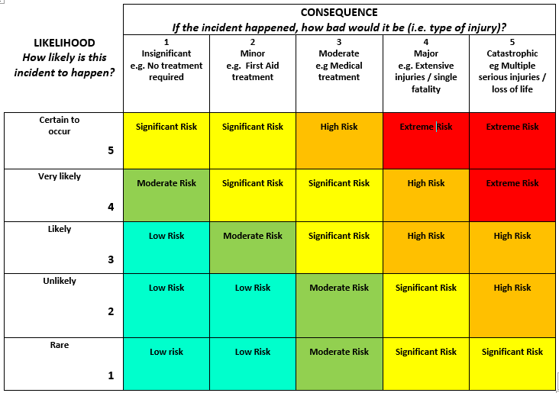

PART 3 Determine Management Controls using the hierarchy of controls
Responsible Persons |  | Control Options | Priority for Control
Extreme or High Risk | Senior Management | Cease Work, isolate risk, adopt high order controls | 1
Significant or Moderate Risk | Line Manage | Minimise activity, implement higher order controls | 2
Low Risk | Team leaders or User Group | Perform within defined controls, seek higher order controls | 3

Hierarchy of Controls
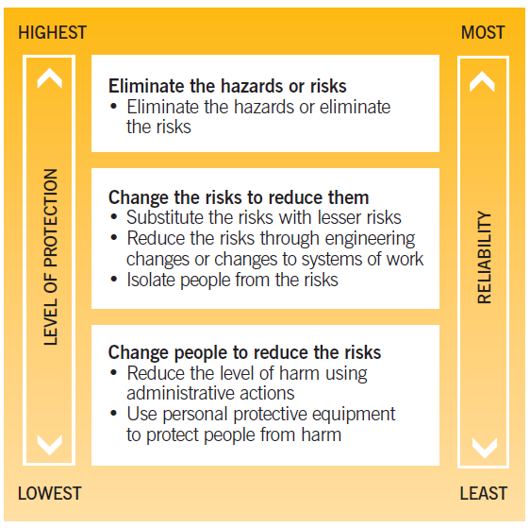

RISK MANAGEMENT FORM
Activity/Area/Issue
Assessed by |  | Date of Assessment:

Hazard | Risk Assessment |  |  | Risk Control | Person Responsible
 | Likelihood | Consequences | Level of Risk

